# Lab: Data Encryption

|  |
| --- |
| * This is worth 2 points. * The due date is tomorrow midnight. * Use the following naming convention: homework, underscore, last name, first initial, and extension (e.g., Lab_Encrypt_ImG.docx). |

## 1. Preparation

First, if your SQL Server does not have Oldhouse database, create it using this script: **Oldhouse-Table-Create (Lab).sql**.

Next, perform the lab using this script: **Encryption-Cert (Lab).sql**.

## 2. Deliverables

-- Display the original table

select * from dbo.cust

go

/* Task #1: Show the original table in a screen shot. */

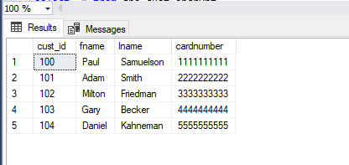

-- Display the encrypted table

select * from dbo.cust_encrypt

go

/* Task #2: Show the encrypted table in a screen shot. Also, explain why we need to change the data type for encryption. */

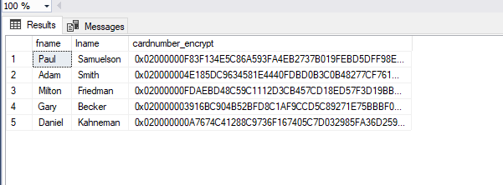

Data type must be changed if need to add encryption and we are using column level encryption as this type is not secure and it only relies on a single key management hierarchy, so in this case if we insert a paraphrase it will revert back to its actual data.

-- Display the encrypted table

select * from dbo.cust_encrypt

go

/* Task #3: Show the encrypted table in a screen shot. Also, explain the encryption process after Task #2. */

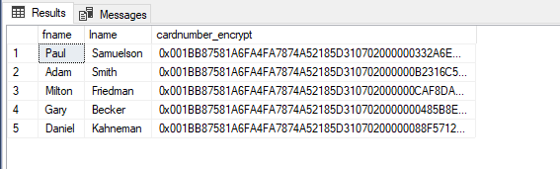

This encryption method is done by using certificate, to do this we have to create a certificate with a symmetric key and then truncate the table. When decrypting we use the certificate and insert the information we want back to the table.

-- Display the decrypted table

select fname,

lname,

cardnumber = convert(nvarchar(25), DecryptByKey(cardnumber_encrypt))

from dbo.cust_encrypt

go

/* Task #4: Show the encrypted table in a screen shot. Also, explain the decryption process after Task #3. */

/* Did you get the original data back? If not, what's wrong? */

/* Hint: Check out the current data type of cardnumber with the original one */

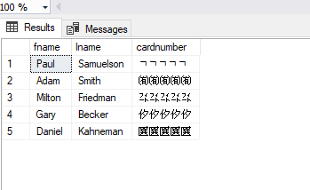

I did not get the original data back, this is because the data type of the decrypted table is nvarchar and the original is varchar, varcgat is ASCII and nvarchat is unicoded.

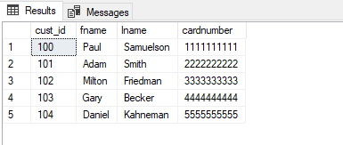

This is what I got when changed it back in the select statement